CSE 5522 HW9

Professor: Jim Davis

Yi Zhao

1. The matrix P has the value below:



The calculated SSE is: **18.7461**.

1. Here is the projected point from image1 and the origin image2. The calculated SSE is **105.9739**. According to the image below, the points are mostly lying on origin points from image2.

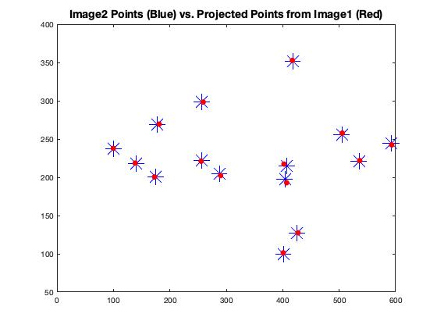

% Author: Yi Zhao

% CSE 5524, HW9

% 11/3/2019

%%%%%%%%%%%%%%%%%%%%%%%%%%%%%%%

%% Problem 1

% load 2d and 3d data

data2d = load('data/2Dpoints.txt');

data3d = load('data/3Dpoints.txt');

x = data2d(:,1); y = data2d(:,2);

X = data3d(:,1); Y = data3d(:,2); Z = data3d(:,3);

one = ones(size(data2d,1), 1); zero = zeros(size(data2d, 1), 1);

% construct matrix A

A = zeros(2*size(data2d,1), 12);

A(1:2:end, :) = [X,Y,Z,one,zero,zero,zero,zero,-X.*x, -Y.*x, -Z.*x, -x];

A(2:2:end, :) = [zero,zero,zero,zero,X,Y,Z,one,-X.*y, -Y.*y, -Z.*y, -y];

% calculate p value

[V, D] = eig(A'*A);

p = V(:, 1); % eigenvector with smallest egvalue

p = reshape(p, 4, [])';

disp(p)

%%%%%%%%%%%%%%%%%%%%%%%%%%%%%%%

%% Problem 2

% calculate homogeneous 3d array and 2d array

origin3dArr = [data3d, one]';

result2dArr = p * origin3dArr;

% switch result to inhomogeneous and reshape to same size as input 2d array

result2d = [result2dArr(1,:)./result2dArr(3,:); result2dArr(2,:)./result2dArr(3,:)];

result2d = reshape(result2d, [], size(data2d,1))';

% calculate sum of squared error

error = sum((result2d - data2d).^2, 'all');

disp(error)

%%%%%%%%%%%%%%%%%%%%%%%%%%%%%%%

%% Problem 3

% load data for im1x, im1y, im2x, im2y

data = load('data/homography.txt');

im1x = data(:,1); im1y = data(:,2); im2x = data(:,3); im2y = data(:,4);

one = ones(size(data,1), 1); zero = zeros(size(data, 1), 1);

% calculate Ta and Tb

sa = sqrt(2)/(mean(sqrt((im1x-mean(im1x)).^2 + (im1y-mean(im1y)).^2),'all'));

sb = sqrt(2)/(mean(sqrt((im2x-mean(im2x)).^2 + (im2y-mean(im2y)).^2),'all'));

Ta = [sa,0,-sa*mean(im1x); 0,sa,-sa*mean(im1y); 0,0,1];

Tb = [sb,0,-sb*mean(im2x); 0,sb,-sb*mean(im2y); 0,0,1];

% get origin data transformed using calculated s

im1x = sa*(im1x-mean(im1x));

im1y = sa*(im1y-mean(im1y));

im2x = sb*(im2x - mean(im2x));

im2y = sb*(im2y - mean(im2y));

% construct A

A = zeros(2*size(im1x, 1), 9);

A(1:2:end, :) = [im1x, im1y, one, zero, zero, zero, -im1x.*im2x, -im1y.*im2x, -im2x];

A(2:2:end, :) = [zero, zero, zero, im1x, im1y, one, -im1x.*im2y, -im1y.*im2y, -im2y];

% calculate homography h

[V, D] = eig(A'*A);

h = V(:, 1); % eigenvector with smallest egvalue

h = reshape(h, 3, [])';

% calculate H

H = inv(Tb)* h * Ta;

disp(H)

%%%%%%%%%%%%%%%%%%%%%%%%%%%%%%%

%% Problem 4 and 5

% construct projected result

origin2dArr = [data(:,1), data(:,2), one]';

result2dArr = H * origin2dArr;

result2d = [result2dArr(1,:)./result2dArr(3,:); result2dArr(2,:)./result2dArr(3,:)];

result2d = reshape(result2d, [], size(data,1))';

% plot projected from image1 and origin value of image2

plot(data(:,3), data(:,4), 'b*', result2d(:,1), result2d(:,2), 'r.', 'MarkerSize', 20)

title('Image2 Points (Blue) vs. Projected Points from Image1 (Red)','FontSize', 14)

% calculate error

error = sum((result2d - data(:, 3:4)).^2, 'all');

disp(error)